|  |  |  |  |  |
| --- | --- | --- | --- | --- |
| by Unknown Author is licensed under |  | |  | | --- | | Stage 3 Newsletter | | Beecroft Public School | |
|  |  |  |
| Term 2 2018 |  | Week 2 |

# Welcome back

Welcome back. We hope that everyone is well rested and ready for a term full of exciting learning.

Curriculum

An overview of this term’s teaching/learning experiences:

History

This term we continue our unit Australia as a Nation.

This topic moves from colonial Australia to the development of Australia as a nation, particularly after 1901. Students will have an understanding of Federation and the experiences of democracy and citizenship over time. They will understand the significance of Australia’s British heritage, the Westminster system and understand the people and processes involved in legislative, executive and judicial functions of state and federal governments

English

Grade literacy will support the History units as well as individual class activities. Novel studies –

Stage 3 Novel – *Beetle Boy* by M G Leonard

Students will need their own copy of the grade novel in either book or digital form.

The Children’s Bookshop in Beecroft has limited copies available for purchase.

Mathematics

Topics will come from the Mathematic Strands: Number and Algebra, Measurement and Geometry, Statistics and Probability with working mathematically incorporated into each.

Science

Year 5 - Earth’s Place in Space

Year 6 - Light Shows

OC - Sustainability

Creative Arts

Class tasks to support units

PDHPE

Welfare – Friendly Schools Plus, Peer Support

Peer Support

Year 6 students will lead our whole school Peer Support Program ‘*Moving Forward’* that focuses on resilience. Our Peer Support lessons will commence in Week 2.

Sport

Year 6 PSSA (soccer and netball)

Year 5/6 (soccer – Western Sydney Wanderers)

Year 5 and 6 - Athletics

Stage 3 students will need to wear their Sports uniform on **Thursdays and Fridays**.

Equipment

Items will need to be replenished as needed. Please ensure that your child has the following: Dictionary/Thesaurus, Maths Equipment – (compass, protractor, ruler), USB on a lanyard, earphones, scissors, glue, pens, lead pencils, coloured pencils, black fine liner, highlighters, 2 envelope folders and an A3 art book (if not already purchased)

General Organisation

Uniform – We will transition to winter uniform over the next two weeks. Students are reminded that they must wear the correct uniform at school. This includes a school hat and the right colour/type of socks. Girls are reminded that jewellery is not part of the uniform and should not be worn.

Please make sure that your child has a water bottle and a healthy recess and lunch each day. All belongings must be clearly labelled with your child’s name and class.

### *Peer Support Training Term 1*

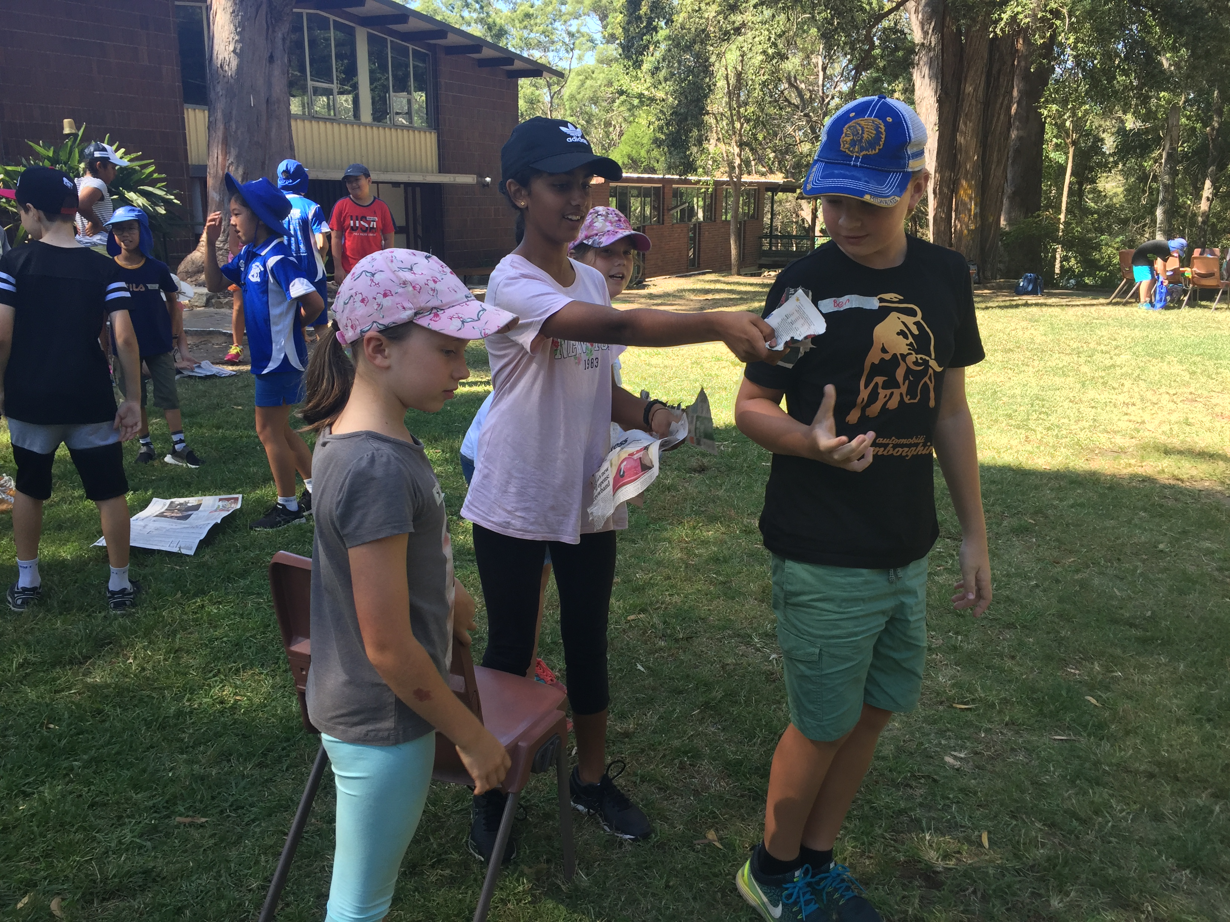

Students seeking scholarships.

We appreciate that some of our Year 6 students will be seeking scholarships to a variety of private schools throughout this year. Please note that we are unable to provide references for students or to mark work which has been completed outside of the school for inclusion in portfolios.

Parent/Teacher interviews

Please note that parent/teacher interviews will occur on Wednesday 27th June and Thursday 28th June. More information regarding interviews will be sent home later in the term.

Teachers taking leave in Term 2

Mrs. B. Johnson (6J)

12/6 – 27/7

6J will be taught by Mrs. Hermann

Dates for your diary

Tuesday 8th May

– Cross Country Carnival

Thursday 10th May

– Mother’s Day stall

Friday 11th May

– PSSA begins

Tuesday 15th May

– Tuesday 22nd May NAPLAN online (Year 5)

Wednesday 6th June

– Year 5 to Canberra

Wednesday 27th June & Thursday 28th June

– Stage 3 Parent/Teacher interviews

*We look forward to another engaging term of learning. Thank you for your support.*

*Ellen Randall Stage 3 Teachers*

*Stage 3 Supervisor*